# Acknowledgement

The success and final outcome of this assignment required a lot of guidance and assistance from many people and I am extremely fortunate to have got this all along the completion of my assignment work. Whatever I have done is only due to such guidance and assistance and I would not forget to thank them.

I respect and thank Mr. A.R.M.Nizzad Sir for giving me an opportunity to do this assignment on time, I extremely grateful to him for providing such a nice support and guidance. I am really grateful because I managed to complete this assignment within the time given by my lecturer. This assignment cannot be completed without the effort and co-operation from my class mates. I would like to express my gratitude to my friends and respondents for support and willingness to spend some time with me.

S. SHALOMSHAN

# Introduction

Advance programming is a subject that contain all programming language paradigms and Object-oriented programming is a programming language model organized around the objects rather than “action” and data rather than logic. Historically, a program has been viewed as a logical procedure that takes input data, processes it, and produces output data.

In this assignment I have required to develop software system for a Book Store before that I have to understand the Advance Programming principles and able to designing the object-oriented programming solution.

Implement the solution, designing the algorithm. Finally, I have maintained the source code in the GitLab and have a report as well as testing and maintenance plan for the developed system.

Contents

Acknowledgement 1

Introduction 2

Tables of Figures 4

Part: -01 5

What is Object Oriented Programming? 5

Benefits of OOP 6

How to structure OOP programs 7

Building blocks of OOP 9

Classes 10

Objects 11

Attributes 12

Methods 12

Four Principles of OOP 14

Inheritance 14

Encapsulation 17

Abstraction 21

Polymorphism 22

Method Overriding 22

Methods Overloading 23

Conclusion 25

Part: -02 26

Create UML diagrams that refine from each derived version from the scenario 26

Justification 26

Part: - 03 27

Implement Code Applying Design Patterns 27

Justification 28

Part: -04 29

Design Pattern for The Scenario 29

Why I choose 29

Conclusion 30

Reference 31

# Tables of Figures

Figure 1 Class blueprint being used to create two Car type objects, myCar and helensCar 6

Figure 2 TrackingDog's overriding the bark() method 23

Figure 3 UML Class Diagram 26

Figure 4 Source Code 27

Figure 5 Application View 27

Figure 6 Source Code Path Way 28

# Part: -01

# What is Object Oriented Programming?

Object Oriented programming (OOP) is a programming paradigm that relies on the concept of classes and objects. It is used to structure a software program into simple, reusable pieces of code blueprints (usually called classes), which are used to create individual instances of objects. There are many object-oriented programming languages including JavaScript, C++, Java, and Python.

A class is an abstract blueprint used to create more specific, concrete objects. Classes often represent broad categories, like Car or Dog that share attributes. These classes define what attributes an instance of this type will have, like color, but not the value of those attributes for a specific object.

Classes can also contain functions, called methods available only to objects of that type. These functions are defined within the class and perform some action helpful to that specific type of object.

**For Example: -** Our Car class may have a method repaint that changes the color attribute of our car. This function is only helpful to objects of type Car, so we declare it within the Car class thus making it a method.

Class templates are used as a blueprint to create individual objects. These represent specific examples of the abstract class, like myCar or goldenRetriever. Each object can have unique values to the properties defined in the class.

**For Example: -** say we created a class, Car, to contain all the properties a car must have, color, brand, and model. We then create an instance of a Car type object, myCar to represent my specific car.

We could then set the value of the properties defined in the class to describe my car, without affecting other objects or the class template.

We can then reuse this class to represent any number of cars.

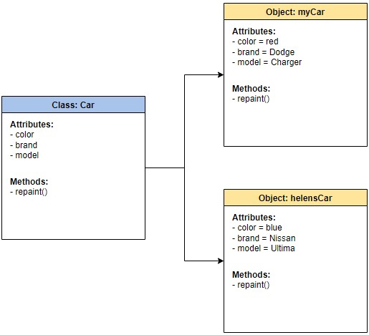

Figure 1 Class blueprint being used to create two Car type objects, myCar and helensCar

## Benefits of OOP

* OOP models complex things as reproducible, simple structures
* Reusable, OOP objects can be used across programs
* Allows for class-specific behavior through polymorphism
* Easier to debug, classes often contain all applicable information to them
* Secure, protects information through encapsulation

# How to structure OOP programs

Let’s take a real-world problem, and conceptually design an OOP software program.

Imagine running a dog sitting camp, with hundreds of pets, and you have to keep track of the names, ages, and days attended for each pet. How would you design simple, reusable software to model the dogs?

With hundreds of dogs, it would be inefficient to write unique code for each dog. Below we see what that might look like with objects rufus and fluffy.

//Object of one individual dog

var rufus = {

name: "Rufus",

birthday: "2/1/2017",

age: function() {

return Date.now() - this.birthday;

},

attendance: 0

}

//Object of second individual dog

var fluffy = {

name: "Fluffy",

birthday: "1/12/2019",

age: function() {

return Date.now() - this.birthday;

},

attendance: 0

}

As you can see above, there is a lot of duplicated code between both objects. The age() function appears in each object. Since we want the same information for each dog, we can use objects and classes instead.

**Grouping related information together** to form a class structure makes the code shorter and easier to maintain.

In the dogsitting example, here’s how a programmer could think about organizing an OOP:

1. **Create a parent class for all dogs** as a blueprint of information and behaviors (methods) that all dogs will have, regardless of type.
2. **Create child classes** to represent different subcategories of dog under the generic parent blueprint.
3. **Add unique attributes and behaviors** to the child classes to represent differences
4. **Create objects from the child class** that represent dogs within that subgroup

The diagram below represents how to design an OOP program: grouping the related data and behaviors together to form a simple template then creating subgroups for specialized data and behavior.

The Dog class is a generic template, containing only the structure about data and behaviors common to all dogs.

We then create two child classes of Dog, HerdingDog and TrackingDog. These have the inherited behaviors of Dog (bark()) but also behavior unique to dogs of that subtype.

Finally, we create objects of the HerdingDog type to represent the individual dogs Fluffy and Maisel.

We can also create objects like Rufus that fit under the broad class of Dog but do not fit under either HerdingDog or TrackingDog.

## Building blocks of OOP

Next, we’ll take a deeper look at each of the fundamental building blocks of an OOP program used above:

* Classes
* Objects
* Methods
* Attributes

## Classes

In a nutshell, classes are essentially user defined data types. Classes are where we create a blueprint for the structure of methods and attributes. Individual objects are instantiated, or created from this blueprint.

Classes contain fields for attributes, and methods for behaviors. In our Dog class example, attributes include name & birthday, while methods include bark() and updateAttendance().

Here’s a code snippet demonstrating how to program a Dog class using the JavaScript language.

class Dog {

constructor(name, birthday) {

this.name = name;

this.birthday = birthday;

}

//Declare private variables

_attendance = 0;

getAge() {

//Getter

return this.calcAge();

}

calcAge() {

//calculate age using today's date and birthday

return Date.now() - this.birthday;

}

bark() {

return console.log("Woof!");

}

updateAttendance() {

//add a day to the dog's attendance days at the petsitters

this._attendance++;

}

Remember the class is a template for modeling a dog, and an object is instantiated from the class representing an individual real-world thing.

## Objects

Of course OOP includes objects! Objects are instances of classes created with specific data, for example in the code snippet below Rufus is an instance of the Dog class.

class Dog {

constructor(name, birthday) {

this.name = name;

this.birthday = birthday;

}

//Declare private variables

_attendance = 0;

getAge() {

//Getter

return this.calcAge();

}

calcAge() {

//calculate age using today's date and birthday

return Date.now() - this.birthday;

}

bark() {

return console.log("Woof!");

}

updateAttendance() {

//add a day to the dog's attendance days at the petsitters

this._attendance++;

}

}

//instantiate a new object of the Dog class, and individual dog named Rufus

const rufus = new Dog("Rufus", "2/1/2017");

When the new class Dog is called:

* A new object is created named rufus
* The constructor runs name & birthday arguments, and assigns values.

## Attributes

Attributes are the information that is stored. Attributes are defined in the Class template. When objects are instantiated, individual objects contain data stored in the Attributes field.

The state of an object is defined by the data in the object’s attributes fields. For example, a puppy and a dog might be treated differently at pet camp. The birthday could define the state of an object, and allow the software to handle dogs of different ages differently.

## Methods

Methods represent behaviors. Methods perform actions; methods might return information about an object, or update an object’s data. The method’s code is defined in the class definition.

When individual objects are instantiated, these objects can call the methods defined in the class. In the code snippet below, the bark method is defined in Dog class, and the bark() method is called on the Rufus object.

class Dog {

//Declare protected (private) fields

_attendance = 0;

constructor(name, birthday) {

this.namee = name;

this.birthday = birthday;

}

getAge() {

//Getter

return this.calcAge();

}

calcAge() {

//calculate age using today's date and birthday

return this.calcAge();

}

bark() {

return console.log("Woof!");

}

updateAttendance() {

//add a day to the dog's attendance days at the petsitters

this._attendance++;

}

}

Methods often modify, update or delete data. Methods don’t have to update data though. For example the bark() method doesn’t update any data because barking doesn’t modify any of the attributes of the Dog class: name or birthday.

The updateAttendance() method adds a day the Dog attended the pet sitting camp. The attendance attribute is important to keep track of for billing Owners at the end of the month.

Methods are how programmers promote reusability, and keep functionality encapsulated inside an object. This reusability is a great benefit when debugging. If there’s an error, there’s only one place to find it and fix it instead of many.

The underscore in _attendance denotes that the variable is protected, and shouldn’t be modified directly. The updateAttendance() method is used to change _attendance.

## Four Principles of OOP

The four pillars of object-oriented programming are:

* **Inheritance:** child classes inherit data and behaviors from parent class
* **Encapsulation:** containing information in an object, exposing only selected information
* **Abstraction:** only exposing high level public methods for accessing an object
* **Polymorphism:** many methods can do the same task

## Inheritance

Inheritance allows classes to inherit features of other classes. Put another way, parent classes extend attributes and behaviors to child classes. Inheritance supports reusability.

If basic attributes and behaviors are defined in a parent class, child classes can be created extending the functionality of the parent class, and adding additional attributes and behaviors.

For example, herding dogs have the unique ability to herd animals. In other words, all herding dogs are dogs, but not all dogs are herding dogs. We represent this difference by creating a child class HerdingDog from the parent class Dog, and then add the unique herd() behavior.

The benefits of inheritance are programs can create a generic parent class, and then create more specific child classes as needed. This simplifies overall programming, because instead of recreating the structure of the Dog class multiple times, child classes automatically gain access to functionalities within their parent class.

In the following code snippet, child class HerdingDog inherits the method bark from the parent class Dog, and the child class adds an additional method, herd().

//Parent class Dog

class Dog{

//Declare protected (private) fields

_attendance = 0;

constructor(namee, birthday) {

this.name = name;

this.birthday = birthday;

}

getAge() {

//Getter

return this.calcAge();

}

calcAge() {

//calculate age using today's date and birthday

return this.calcAge();

}

bark() {

return console.log("Woof!");

}

updateAttendance() {

//add a day to the dog's attendance days at the petsitters

this._attendance++;

}

}

//Child class HerdingDog, inherits from parent Dog

class HerdingDog extends Dog {

constructor(name, birthday) {

super(name);

super(birthday);

}

herd() {

//additional method for HerdingDog child class

return console.log("Stay together!")

}

}­­­

Notice that the HerdingDog class does not have a copy of the bark() method, it inherits the bark() method defined in the parent Dog class.

When the code calls fluffy.bark() method, the bark() method walks up the chain of child to parent classes, to find where the bark method is defined.

//Parent class Dog

class Dog{

//Declare protected (private) fields

_attendance = 0;

constructor(namee, birthday) {

this.name = name;

this.birthday = birthday;

}

getAge() {

//Getter

return this.calcAge();

}

calcAge() {

//calculate age using today's date and birthday

return this.calcAge();

}

bark() {

return console.log("Woof!");

}

updateAttendance() {

//add a day to the dog's attendance days at the petsitters

this._attendance++;

}

}

//Child class HerdingDog, inherits from parent Dog

class HerdingDog extends Dog {

constructor(name, birthday) {

super(name);

super(birthday);

}

herd() {

//additional method for HerdingDog child class

return console.log("Stay together!")

}

}

//instantiate a new HerdingDog object

const fluffy = new HerdingDog("Fluffy", "1/12/2019");

fluffy.bark();

In JavaScript, inheritance is also known as prototyping. A prototype object acts as a template for another object to inherit properties and behaviors from. There can be multiple prototype object templates, creating a prototype chain.

This is the same concept as the parent/child inheritance. Inheritance is from parent to child. In our example all three dogs can bark, but only Maisel and Fluffy can herd.

The herd() method is defined in the child HerdingDog class, so the two objects, Maisel and Fluffy, instantiated from the HerdingDog class have access to the herd() method.

Rufus is an object instantiated from the parent class Dog, so Rufus only has access to the bark() method.

## Encapsulation

Encapsulation means containing all important information inside an object, and only exposing selected information to the outside world. Attributes and behaviors are defined by code inside the class template.

Then, when an object is instantiated from the class, the data and methods are encapsulated in that object. Encapsulation hides the internal software code implementation inside a class, and hides internal data of inside objects.

Encapsulation requires defining some fields as private and some as public.

* **Private/ Internal interface:** methods and properties, accessible from other methods of the same class.
* **Public / External Interface:** methods and properties, accessible also from outside the class.

Let’s use a car as a metaphor for encapsulation. The information the car shares with the outside world, using blinkers to indicate turns, are public interfaces. In contrast, the engine is hidden under the hood.

It’s a private, internal interface. When you’re driving a car down the road, other drivers require information to make decisions, like whether you’re turning left or right. However, exposing internal, private data like the engine temperature, would just confuse other drivers.

Encapsulation adds security. Attributes and methods can be set to private, so they can’t be accessed outside the class. To get information about data in an object, public methods & properties are used to access or update data.

Within classes, most programming languages have public, protected, and private sections. Public is the limited selection of methods available to the outside world, or other classes within the program. Protected is only accessible to child classes.

Private code can only be accessed from within that class. To go back to our dog/owner example, encapsulation is ideal so owners can’t access private information about other people’s dogs.

//Parent class Dog

class Dog{

//Declare protected (private) fields

_attendance = 0;

constructor(namee, birthday) {

this.name = name;

this.birthday = birthday;

}

getAge() {

//Getter

return this.calcAge();

}

calcAge() {

//calculate age using today's date and birthday

return this.calcAge();

}

bark() {

return console.log("Woof!");

}

updateAttendance() {

//add a day to the dog's attendance days at the petsitters

this._attendance++;

}

}

//instantiate a new instance of Dog class, an individual dog named Rufus

const rufus = new Dog("Rufus", "2/1/2017");

//use getter method to calculate Rufus' age

rufus.getAge();

Consider the getAge() method in our example code, the calculation details are hidden inside the Dog class. The rufus object uses the getAge() method to calculate Rufus’s age.

**Encapsulating & updating data:** Since methods can also update an object’s data, the developer controls what values can be changed through public methods.

This allows us to **hide important information** that should not be changed from both phishing and the more likely scenario of other developers mistakenly changing important data.

Encapsulation adds security to code and makes it easier to collaborate with external developers. When you’re programming to share information with an external company, you wouldn’t want to expose the classes’ templates or private data because your company owns that intellectual property.

Instead, developers create public methods that allow other developers to call methods on an object. Ideally, these public methods come with documentation for the external developers.

The benefits of encapsulation are summarized here:

* **Adds security:** Only public methods and attributes are accessible from the outside
* **Protects against common mistakes**: Only public fields & methods accessible, so developers don’t accidentally change something dangerous
* **Protects IP:** Code is hidden in a class, only public methods are accessible by the outside developers
* **Supportable:** Most code undergoes updates and improvements
* **Hides complexity:** No one can see what’s behind the object’s curtain!

## Abstraction

Abstraction means that the user interacts with only selected attributes and methods of an object. Abstraction uses simplified, high-level tools, to access a complex object.

* Using simple things to represent complexity
* Hide complex details from user

Abstraction is using simple classes to represent complexity. Abstraction is an extension of encapsulation. For example, you don’t have to know all the details of how the engine works to drive a car.

A driver only uses a small selection of tools: like gas pedal, brake, steering wheel, blinker. The engineering is hidden from the driver. To make a car work, a lot of pieces have to work under the hood, but exposing that information to the driver would be a dangerous distraction.

Abstraction also serves an important security role. By only displaying selected pieces of data, and only allowing data to be accessed through classes and modified through methods, we protect the data from exposure. To continue with the car example, you wouldn’t want an open gas tank while driving a car.

The benefits of abstraction are summarized below:

* Simple, high level user interfaces
* Complex code is hidden
* Security
* Easier software maintenance
* Code updates rarely change abstraction

## Polymorphism

Polymorphism means designing objects to share behaviors. Using inheritance, objects can override shared parent behaviors, with specific child behaviors. Polymorphism allows the same method to execute different behaviors in two ways: method overriding and method overloading.

## Method Overriding

Runtime polymorphism uses method overriding. In method overriding, a child class can provide a different implementation than its parent class. In our dog example, we may want to give TrackingDog a specific type of bark different than the generic dog class.

//Parent class Dog

class Dog{

//Declare protected (private) fields

_attendance = 0;

constructor(namee, birthday) {

this.name = name;

this.birthday = birthday;

}

getAge() {

//Getter

return this.calcAge();

}

calcAge() {

//calculate age using today's date and birthday

return this.calcAge();

}

bark() {

return console.log("Woof!");

}

updateAttendance() {

//add a day to the dog's attendance days at the petsitters

this._attendance++;

}

}

//Child class TrackingDog, inherits from parent

class TrackingDog extends Dog {

constructor(name, birthday)

super(name);

super(birthday);

}

track() {

//additional method for TrackingDog child class

return console.log("Searching...")

}

bark() {

return console.log("Found it!");

}

//instantiate a new TrackingDog object

const duke = new TrackingDog("Duke", "1/12/2019");

duke.bark(); //returns "Found it!"

Figure 2 TrackingDog's overriding the bark() method

## Methods Overloading

Compile Time polymorphism uses method overloading. Methods or functions may have the same name, but a different number of parameters passed into the method call. Different results may occur depending on the number of parameters passed in.

//Parent class Dog

class Dog{

//Declare protected (private) fields

_attendance = 0;

constructor(namee, birthday) {

this.name = name;

this.birthday = birthday;

}

getAge() {

//Getter

return this.calcAge();

}

calcAge() {

//calculate age using today's date and birthday

return this.calcAge();

}

bark() {

return console.log("Woof!");

}

updateAttendance() {

//add a day to the dog's attendance days at the petsitters

this._attendance++;

}

updateAttendance(x) {

//adds multiple to the dog's attendance days at the petsitters

this._attendance = this._attendance + x;

}

}

//instantiate a new instance of Dog class, an individual dog named Rufus

const rufus = new Dog("Rufus", "2/1/2017");

rufus.updateAttendance(); //attendance = 1

rufus.updateAttendance(4); // attendance = 5

In this code example, if no parameters are passed into the updateAttendance() method. One day is added to the count. If a parameter is passed in updateAttendance(4), then 4 is passed into the x parameter in updateAttendance(x), and 4 days are added to the count.

The benefits of Polymorphism are:

* Objects of different types can be passed through the same interface
* Method overriding
* Method overloading

## Conclusion

Object Oriented programming requires thinking about the structure of the program and planning at the beginning of coding. Looking at how to break up the requirements into simple, reusable classes that can be used to blueprint instances of objects. Overall, implementing OOP allows for better data structures and reusability, saving time in the long run.

# Part: -02

# Create UML diagrams that refine from each derived version from the scenario

Figure 3 UML Class Diagram

## Justification

CoolBiz (pvt) is an agency they supply items to their clients and collect the payment later. In such cash, they use a payment collector who collects the payment from the clients and handover to CoolBiz. However, recently they found a malpractice by the cash collector where he doesn’t return the full amount of paid by the client. Therefore, CoolBiz wants a simple solution where upon the receipt of three cash from the cash collector, the system will automatically send SMS to the client so that the client can know that his payment is created with the amount. For this, through SMS based on notification systems, a solution can be provided to the cash collector and clients.

# Part: - 03

# Implement Code Applying Design Patterns

# 

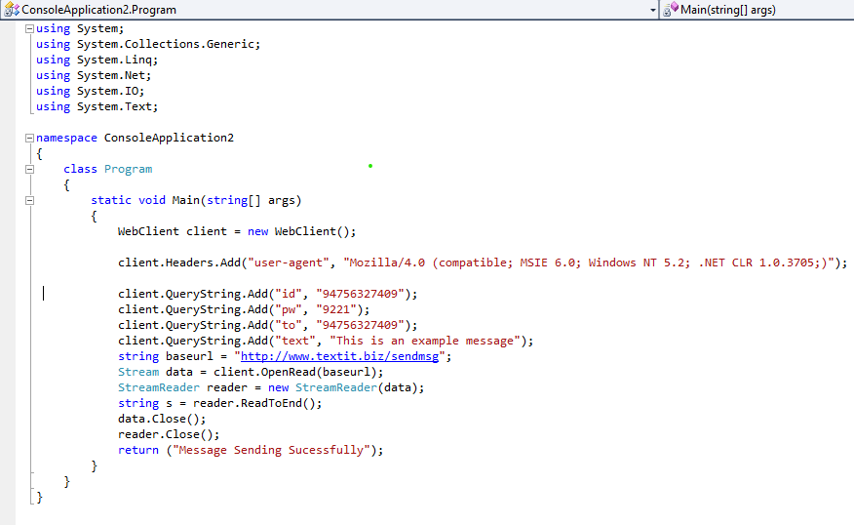

Figure 4 Source Code

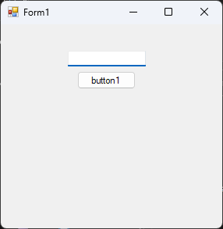

Figure 5 Application View

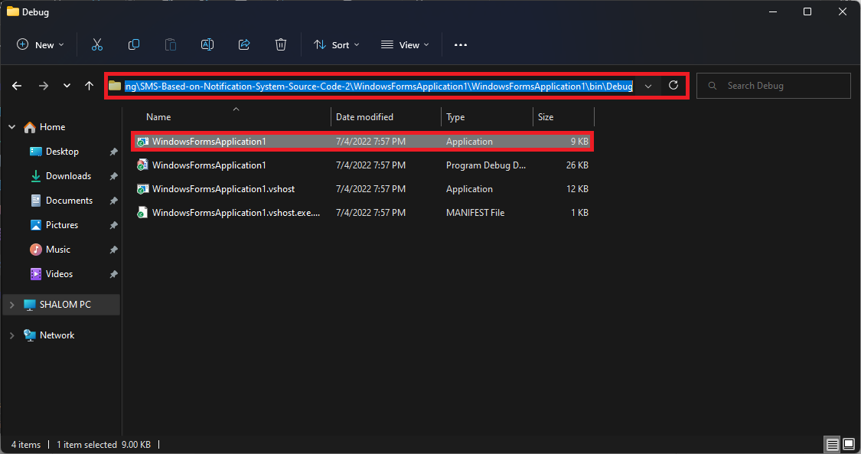

Figure 6 Source Code Path Way

## Justification

CoolBiz (pvt) is an agency they supply items to their clients and collect the payment later. In such cash, they use a payment collector who collects the payment from the clients and handover to CoolBiz. However, recently they found a malpractice by the cash collector where he doesn’t return the full amount of paid by the client. Therefore, CoolBiz wants a simple solution where upon the receipt of three cash from the cash collector, the system will automatically send SMS to the client so that the client can know that his payment is created with the amount. For this, through SMS based on notification systems, a solution can be provided to the cash collector and clients.

GitHub Repo: - <https://github.com/SHALOMSHAN/sms-based-on-notificatio-system.git>

# Part: -04

# Design Pattern for The Scenario

For the scenario of the SMS based on notification systems the builder pattern is suitable for that and builder pattern separates the construction of a complex object from its representation so that the same construction process can create different representations.

## Why I choose

CoolBiz (pvt) is an agency they supply items to their clients and collect the payment later. In such cash, they use a payment collector who collects the payment from the clients and handover to CoolBiz. However, recently they found a malpractice by the cash collector where he doesn’t return the full amount of paid by the client. Therefore, CoolBiz wants a simple solution where upon the receipt of three cash from the cash collector, the system will automatically send SMS to the client so that the client can know that his payment is created with the amount. For this, through SMS based on notification systems, a solution can be provided to the cash collector and clients.

GitHub Repo: - <https://github.com/SHALOMSHAN/sms-based-on-notificatio-system.git>

# Conclusion

Really, I am so happy in completing this assignment because I have learned a lot by doing this assignment and also, whatever the things I missed to understand in the lecturers now with the help of assignment I have understood. And also, now I have the confident in developing the software system an also I have the experience in developing a software system. Mainly I have analysis about test cases for the source code and it was wonderful because they found me some mistakes on my assignment. It was good experience.

# Reference

Available at: http://web.cs.ucla.edu/~palsberg/paper/toplas06.pdf

Available at: https://www.xenonstack.com/insights/what-is-test-driven-development

Available at: https://javapapers.com/oops/association-aggregation-composition-abstraction-generalization-realization-dependency/

Available at: https://jenkov.com/tutorials/java-unit-testing/simple-test.html

Available at: https://martinfowler.com/bliki/SelfTestingCode.html

Available at: https://homepages.ecs.vuw.ac.nz/~kjx/papers/classify.pdf

GitHub Repo: - <https://github.com/SHALOMSHAN/sms-based-on-notificatio-system.git>